Que-1: Create Table Name: Student and Exam

CREATE TABLE student (

Rollno int PRIMARY KEY AUTO_INCREMENT NOT NULL,

Name varchar(25),

Branch varchar(150)

);

INSERT INTO student(Roll_No,Name,Branch) VALUES(1,"Jay","Computer Science"),(2,"Suhani","Electronic and Com"),(3,"Kriti","Electronic and Com");

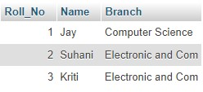

CREATE TABLE Exam (

Rollno int (20),

S_code varchar(50),

Marks int (20),

P_code varchar(50),

FOREIGN KEY (Rollno) REFERENCES student(Roll_No);

);

INSERT INTO exam(Rollno,S_code,Marks,P_code) VALUES(1,"CS11",50,"CS"),(1,"CS12",60,"CS"),(2,"EC101",66,"EC"),(2,"EC102",70,"EC"),(3,"EC101",45,"EC"),(3,"EC102",50,"EC");

